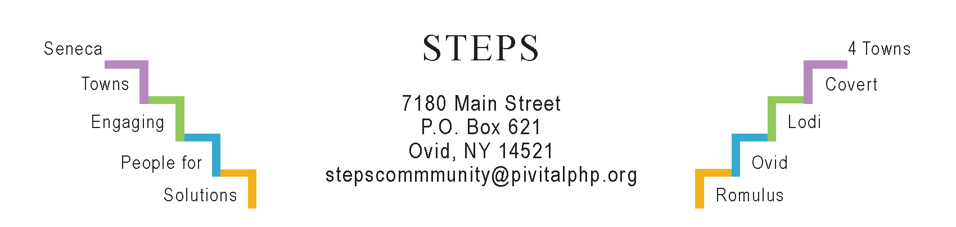

STEPS E3 Meeting Minutes

Monday, 2/26/24 (6:30 pm) by Zoom
Attendees: Karel Titus, Karen Burcroff, Jean Currie, Phil Stannard, Theresa Lahr, Jan Quarles. (Ave Bauder was in Albany and could not attend.)

General Info / Reports (Karel)
- Creating Healthy Schools & Communities: Bike racks and speed-radar signs to be installed in Sheldrake neighborhood. More progress to be reported at next CHSC mtg.
- Willard Task Force: The MRB group has received 5 Letters of Interest from potential developers so far. MRB, IDA, SC Bd of Supervisors, & Willard Task Force are holding a special meeting on Thursday, 2/29/24.
Sustainability (Karel)
- The Climate Smart Community Task Force: The Town of Lodi received a Bronze certificate which makes it more eligible for grants that could be used for flood mitigation.
- The “Lodi Food 4 All” pantry: The Town of Lodi still has no Certificate of Occupancy, so relocation is stalled. Meanwhile, the Pantry is helping Lodi Rod & Gun apply for a $50K grant to upgrade their facilities including the kitchen. The grant appeal is to METRO, a company that makes stainless steel shelving. The Pantry is also applying to Taste of the FLX for up to $10K to provide free meals.
- The Compost Group is paused indefinitely. After conducting a poll, we found there is interest but not enough folks to attend meetings or to lead them. Actual composting continues at our community gardens, schools, and in our backyards.
Reviews & Updates
- Interlaken’s “Water Tower Park”: Cristy Wilcox will complete the sign by April 1st. A fundraiser for the park is in the works, with Sat, May 18 (time TBD), at the tentative date. Location: Cedarwood (Route 96 in Covert, formerly “Brews ‘n Brats”).
- Phase V / STEPS’ sustainability beyond July 2025: STEPS staff are meeting monthly with their funders (Hannah, GRHF). Theresa, Jan, and Judy will also visit a Grants Writers Library in Auburn on Monday, March 18. Carol Sutterby on “Our Town Rocks” in Dundee may speak to STEPS along with Karel and Ave on Thursday, April 4 in the afternoon (time TBA).
- STEPS’ Micro-Enterprise Program: Rose Riley’s secondary loan for her business “Gateway Cleaning” was approved.
- STEPS’ RHPPs: April Hunt is doing rock painting and a sign for the Monarch Garden. Kim Zajac is considering a Art/Mindfulness/Yoga activity.
- STEPS’ Youth Grant from NYS Office of Children & Family Services: 27 kids went bowling in Dec; and 18 kids went ice-skating at Cass Park in Ithaca in Feb. In March STEPS will propose a series of Tae Kwando lessons to take place in the library in Ovid. Extended Day teachers in Interlaken and Romulus are arranging for Caryn Sheckler to teach “Yoga for Strength” in March, April & May. Lawn Games are planned for the Ovid Strawberry Festival in June. Summer camps are being explored. Community Pickleball including kids continues to be popular at the Interlaken Elementary gym. It will increase to 3x/week (Tu, W, and Fris 5:30-8 pm) during March and April; in warmer months, on the HS tennis courts after 6 pm on weekdays.
Upcoming Events / Action Items
SC United Way: Weds, 2/27 (5-7 pm) Ovid Library: “Healthy Housing & Communities”
SC United Way: TH, 3/14: “Healing Circle” at Lux Hotel (formerly Holiday Inn), Waterloo. For details, contact Karen Burcroff <karen@uwseneca.org>
SC United Way: Fri, 3/15 (8:30a-12n) Elks Lodge in Seneca Falls: “Native American Cultural Competency” with Pete Hill.
Mon, Mar 4 (10:30 am) Personal Health & Wellness at STEPS’ office.
E3 Meeting: Mon, March 25 (6:30-7:30 pm) by Zoom
Save-the-date: Mon, May 13 (6:30- 8 pm) RISERS Quarterly gathering at STEPS’ office.

