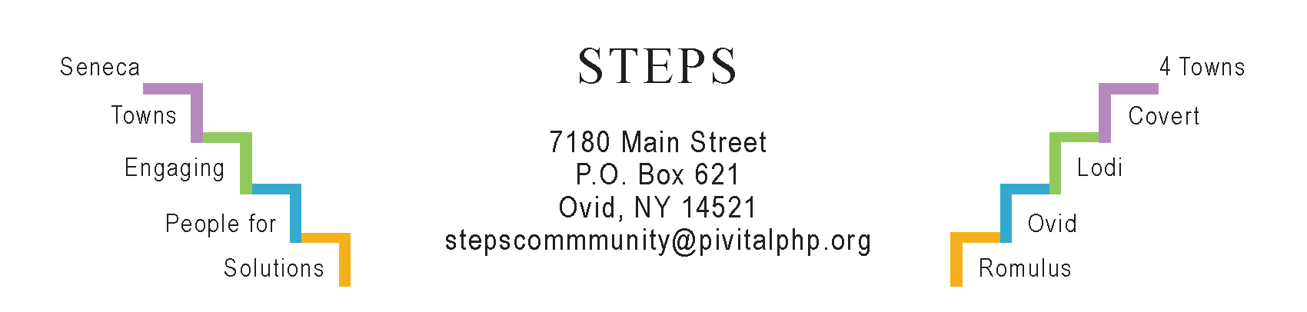

STEPS E3 Meeting Minutes

Monday, 4/22/24 (6:30 pm) by Zoom
Attendees: Karel Titus, Ave Bauder, Karen Burcroff (SC United Way), Sarah Flack (CHSC grant), Tony Del Plato, Carrie Smalser (Literacy Volunteers Dir), Sarah Merritt (UHR), Betty DeLong (Aspire NY), Theresa Lahr, Judy Mellgard, Deborah Puntenney, Jan Quarles (Scribe).

General Info / Reports
- Creating Healthy Schools & Communities (Sarah): We’re in Year 3 of our 5-year CHSC grant. This week, 5 benches, 2 bike racks, & 4 trash receptables are being installed in Ovid. Mo Tidball is leaving CHSC.
- Willard Task Force (Ave): Met last Thursday with Mike. SC Board submitted paperwork, including 3 letters of interest from housing groups, in pursuit of a developer with whom they can partner. RFP can’t be finalized without state approval. Once released, there’s a 90-day turnaround time which will include a tour & pre-admission Q&A. The Economic Development Committee & MRB are in charge. Earlier, Deborah had suggested contacting Louise Wadsworth of Livingston County Development to connect us with Greg O’Connell, a master developer (retired?). Ave will pass on his name to Sarah, Bruce, and Mike.
- More on Willard: On Eclipse Day, Carrie Smalser interacted with John Crispin, the professional photographer who organized a community photography project about Willard last year. Judy suggested The Three Bears invite John & Carrie, along with Bruce or Craig Williams to do a presentation on Willard.
Sustainability (Karel)
- Lodi Task Force: The Climate Smart Communities received 2 grants totaling $15K to work on climate mitigation.
- (Ave) Cornell’s new online course 5/20-6/14: “Climate Advocacy: Making Policy Change.”
- “Lodi Food 4 All:” Food pantries in our county are now open 4 days/wk (M, TH, FRI, & SAT). In addition, a grant pays for food deliveries. Judy: Food Link has committed until December.
Reviews & Updates
- (Tony) Interlaken’s “Water Tower Park:” For the 5/18 benefit, Jodi & Anne Serling will donate a signed copy of the biography of their dad (Rod Serling of Twilight Zone). Peter Garcia (Interlaken trustee) is coordinating a community-build of picnic tables. Event will be at Cedarwood (Tburg). 2-5 pm Kids’ stuff (lawn games, art, etc); 4 pm Hilby the German Juggler; 5 pm dinner (for purchase); 5-9 pm cash bar; vendors; live music. $20.
- Phase V / STEPS’ sustainability beyond July 2025: STEPS staff are meeting monthly with Deborah & Hannah. (TL): We submitted a LOI to Rochester Area Community Foundation.
- STEPS’ RHPPs: Art sessions at Conifer Village on Thursdays; “Take A Hike” booth to connect people with local trails; a 5K race at Strawberry Festival (Jun 15).
- STEPS’ Youth Grant from NYS Office of Children & Family Services (OCFS):
- Tina Felice (7th Dan Black Belt) will teach Tae Kwon Do on 7 Wednesdays in May & June at EBF Library in Ovid. Ages 11-17 (4-5 pm); ages 7-10 (5-5:30 pm).
- Caryn Sheckler is teaching a 6-week series of Yoga & Cardio for Elementary kids (Interlaken) & HS students (Ovid) in Extended Day during April & May.
- Community Pickleball has been popular all winter at the Elem gym. It moves outdoors May 1 to HS tennis courts. 6 pm on school days; any time when school is not in session.
Upcoming Events / Action Items
Mon, May 6 (10:30 am) Personal Health & Wellness at STEPS’ office.
Thurs, May 16 (5:30-8:30 pm) “Taste of Spring” at del Lago
Sat, May 18 (2-9 pm) A family-friendly benefit for Water Tower Park. Cedarwood in Tburg.
Mon, June 3 (11-12:30), Focus group on free genetic screening, EBF Library in Ovid.
Sat, June 8: Olde Home Days in Interlaken.
Fri, June 14: The Yardvarks will play for opening night at the Ovid Farmers Market.
Sat, June 15: Ovid Strawberry Festival. STEPS Wellness Corner will be in the Ovid Firehall.
Sat, July 13: Lodi Festival.

Next E3 Meeting: Mon, May 20 (6:30-7:30 pm) by Zoom

