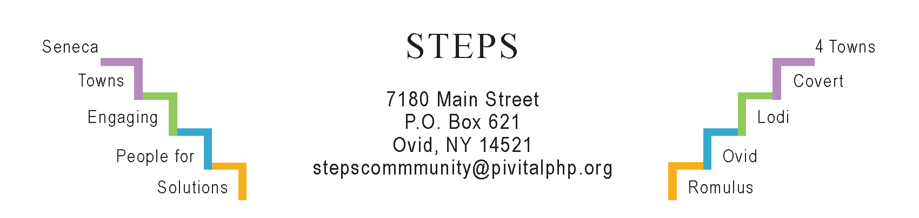

STEPS E3 Meeting Minutes

Monday,1/29/24 (6:30 pm) by Zoom
Attendees: Ave Bauder, Karel Titus, Tom Bouchard, Jean Currie, Phil Stannard, Theresa Lahr, Jan Quarles.

General Info / Reports (Ave)
- SC CCE’s new office is in the Huntington Living Center, Rtes 5 & 20, Waterloo.
- Creating Healthy Schools & Communities: Ovid passed a resolution to participate in “Complete Streets.”
- Willard Task Force: MRB will begin on Monday to negotiate with NYS. Deadline is Feb 9 to receive Letters of Interest.
Sustainability (Karel)
- The Climate Smart Task Force’s workshop on 1/17 at Lodi Library about flood mitigation was attended by 25 people. Presenters were SC Soil & Water, CCE, USDA-NRC & USDA Farm Services Agency.
- The “Lodi Food 4 All” pantry will relocate in April or May. Access to food has increased in our area. A pantry is open in Ovid every Mon & Th; in Interlaken every Fri, and in Lodi every Sat. The Sheldrake neighborhood’s book club gave a substantial end-of-year donation to the Interlaken pantry.
- The next Compost Group will meet virtually on TH, 2/15 at 4 pm, led by Marti.
Reviews & Updates (Ave)
- The South Seneca Board of Education is applying for a NYSERDA grant in late spring for geothermal.
- Interlaken’s “Water Tower Park” (Theresa): Janice Conrad, the fundraising committee’s chair, is on medical leave. Peter Garcia may join. Tony Del Plato,
Gina Nigro, and Theresa may re-apply for a Bonafiglia grant. Kristy Wilcox is making the sign.
- Phase V (Theresa): STEPS will decrease programs this year to develop a plan for its end of funding in July 2025. Theresa has allocated time to discuss this at RISERS on Mon, 2/12 (6:30 pm). Ave suggested we schedule a longer workshop to focus on it.
Upcoming Events / Action Items
Mon, 2/5 (10:30 am) Personal Health & Wellness at STEPS’ office.
Mon, 2/12 (6:30- 8 pm) RISERS Quarterly gathering at STEPS’ office.
Thurs, 2/15 (4 pm) Compost Group meets on Zoom.
Sat, 2/17 (10a-12n) Ovid Firehall. DIY Healthy Cleaning Products (Sarah Strichartz).
Mon, Mar 4 (10:30 am) Personal Health & Wellness at STEPS’ office.
E3 will meet next on Monday, Feb 26th (6:30-7:30 pm) by Zoom

