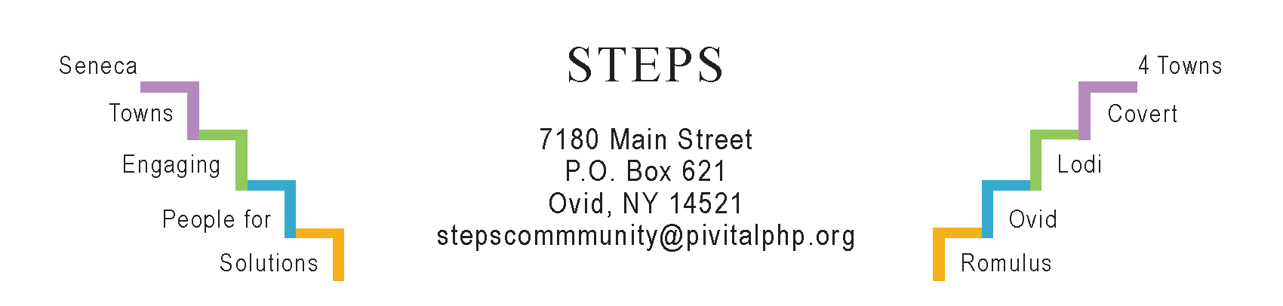

STEPS E3 Meeting Minutes

Monday, 3/25/24 (6:30 pm) by Zoom
Attendees: Karel Titus, Tom Bouchard, Karen Burcroff, Sarah Flack, Phil Stannard, Theresa Lahr, Deborah Puntenney, Jan Quarles. (Ave Bauder could not attend.)

General Info / Reports
- Creating Healthy Schools & Communities (Sarah): Speed signs to be installed in Sheldrake neighborhood. Improvements are happening in Ovid Village. Working on a small path to a sitting area in the back of the EBF Library in Ovid. A Food Meeting took place at the CAP office. Diane Kelly is addressing electrical needs at Ovid Pantry. Romulus School admins will meet in Apr & May to review their policies relevant to state-mandated tri-annual assessments of healthy food & physical activities.
- Willard Task Force (Tom): We met on 3/21, following a tour. Our discussion included forming a selection committee, made up of residents, to seek a developer/master planner. They’d have to follow historic preservation guidelines for certain buildings. SC Board of Supervisors wants to form an LDC. Deborah suggested (again) that we contact Louise Wadsworth of Livingston County Development and ask her to connect us with Greg O’Connell, a master developer (retired?). He has extensive relevant experience that he may be willing to share.
Sustainability (Karel)
- Lodi Task Force: The Climate Smart Communities certification makes them eligible to apply for a $15K grant, with $15K more to be matched by the Town. The funds could be used to help residents cope with extreme rains, like guiding homeowners on how to develop “water-smart” yards; promoting stormwater infrastructure; mapping community assets; assessing well water risks; and/or creating a How-To Guide for landscapers & developers.
- “Lodi Food 4 All” pantry: The Town Hall still awaits a Certificate of Occupancy, delaying the pantry’s relocation, but we’ll have access to the interior in April. The big news is that GRHF (STEPS’ funder) agreed to pay for the new shed!
Reviews & Updates
- Interlaken’s “Water Tower Park”: A family-fun-fundraiser for the park is scheduled for Sat, May 18 (2-5 pm) at “Cedarwood” (Rte 96 in Covert, formerly “Brews ‘n Brats”). FLX BBQ; lawn games; a juggler; and live music (Rich Richardson’s band will play for free).
- Phase V / STEPS’ sustainability beyond July 2025: STEPS staff are meeting monthly with their funders (Hannah, GRHF). Theresa, Jan & Judy did some research at the Grants Writers Library in Auburn on Mar 18. Carol Sutterby on “Our Town Rocks” in Dundee will meet with STEPS staff, Karel, Ave, Phyllis, Deborah, & Michele on TH, Apr 4 (2-5 pm), STEPS office.
- STEPS’ RHPPs: Art sessions at Conifer Village on Thursdays; “Take A Hike” booth to connect people with local trails; a 5K race at Strawberry Festival (Jun 15).
- STEPS’ Youth Grant from NYS Office of Children & Family Services (OCFS):
- Tina Felice (7th Dan Black Belt) will teach Tae Kwon Do on 7 Wednesdays in May & June at EBF Library in Ovid. Ages 7-10 (3:30-4 pm); ages 11-17 (4-5 pm).
- Caryn Sheckler will lead a 6-week series of Yoga & Cardio for Elementary kids (Interlaken) & HS students (Ovid) in Extended Day during April & May.
- Lawn Games are planned for the fundraiser for Water Tower Park on May 18.
- Community Pickleball including kids continues to be popular at the Elementary gym, Interlaken, 3x/week (Tu, W & Fris, 5:30-8 pm) during Mar & Apr.
Upcoming Events / Action Items
Mon, Apr 8 (10:30 am) Personal Health & Wellness at STEPS’ office.
Sat, Apr 27 (10 am – 2 pm) “Take-Back Day” for unused pills: Kinney Drug, Ovid
Thurs, May 16 (5:30-8:30 pm) “Taste of Spring” at del Lago

Next E3 Meeting: Mon, April 22 (6:30-7:30 pm) by Zoom

